**Statistical Machine Learning Approaches to Liver Disease Prediction**

**TEAM ID: PNT2022TMID51504**

**Team Leader :** L.G.Abitha

**Team Member :** S.Sahaya Stepitha

**Team Member :** T.Sajitha

**Team Member :** S.Sowmiya

Project structure

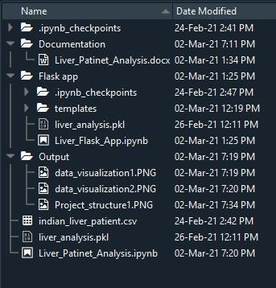

* We have three folders dataset, Flask and Training.
* Dataset has dataset indian_liver_patient.csv.
* A python file called Liver_Flask_App.py for server side scripting.
* We need the model which is saved and the saved model in

this content is liver_analysis.pkl.

* Templates folder which contains home.html and upload.html files.
* Training folder has Liver_Patient_Analysis.ipynb where the model is created and saved.
* Static folder which contains css(styling), fontawe some(styling), img(images), js(Java script) folders to enhance the features of the web page.